|  |  |  |
| --- | --- | --- |
| **Academic Year:** 2024-25 | **Year:** Second Year | **Semester:** II |
| **PRN No.: 1012412079** | **Name: Ratnajeet Patil** | |
| **Subject:** Database Management System | | |
| **Assignment No.**: 6 |  | |
| **Date:** |  | |

**Lab Assignment: 06**

**Title: Nested Queries**: Create and execute nested SQL queries to address real-world scenarios in any database application.

**Execution for:**

Create following tables and insert sample records in it.

* **Orchestras** (id, name, rating, city_origin, country_origin, year)
* **Concerts** (id, city, country, year, rating, orchestra_id (references the orchestras table)).
* **members**table stores the members of (i.e. musicians playing in) each orchestra. The columns are id, name, position (i.e. the instrument played), wage, experience, and orchestra_id (references the orchestras table).

**Frame and solve following queries:**

1. Select the names of all orchestras that have the same city of origin as any city in which any orchestra performed in 2013.
2. List the names and ratings of all orchestras.
3. Find all concerts held in the year 2023.
4. Display all members who play the violin.
5. Find all orchestras with a rating greater than 8.
6. List members with more than 5 years of experience and a wage less than 50,000.
7. List all concerts along with the name of the orchestra that performed.
8. Display each member's name along with the orchestra name they belong to.
9. Find the average rating of concerts for each orchestra.
10. Count the number of members in each orchestra.
11. Get the total wage paid to members for each orchestra.
12. List orchestras that have more than 10 members.
13. Find orchestras with an average member wage greater than 70,000.
14. Find orchestras that have never performed a concert.
15. List the names of members who earn more than the average wage of all members.
16. Display the top 5 highest-rated orchestras in descending order.
17. Find the orchestra(s) with the highest average concert rating.
18. List the top 3 orchestras that pay the highest average wage to their members.
19. Find the names of members who earn more than the highest-paid member of any orchestra from Germany.
20. For each orchestra, list the number of concerts held and the total number of members, only for orchestras formed after the year 2000.

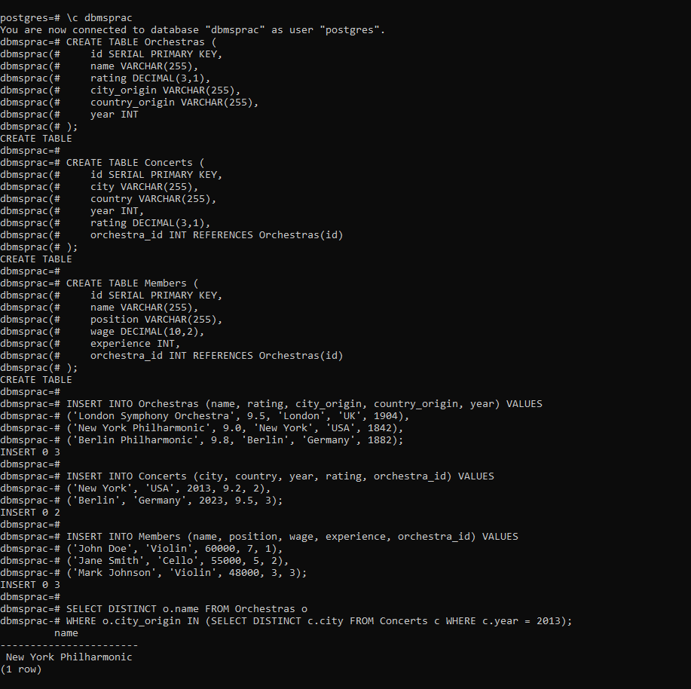

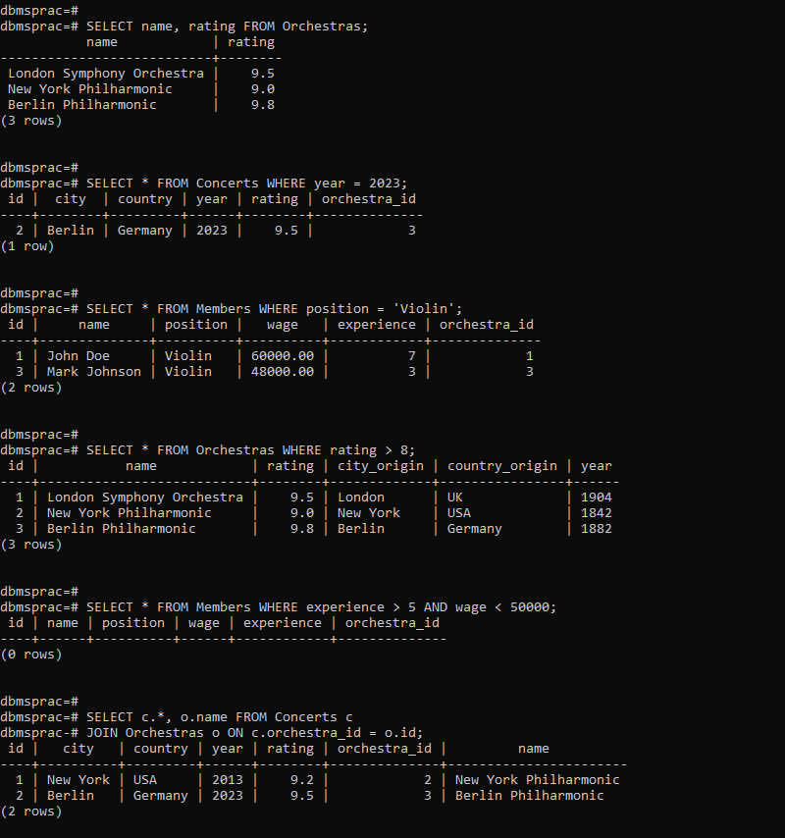

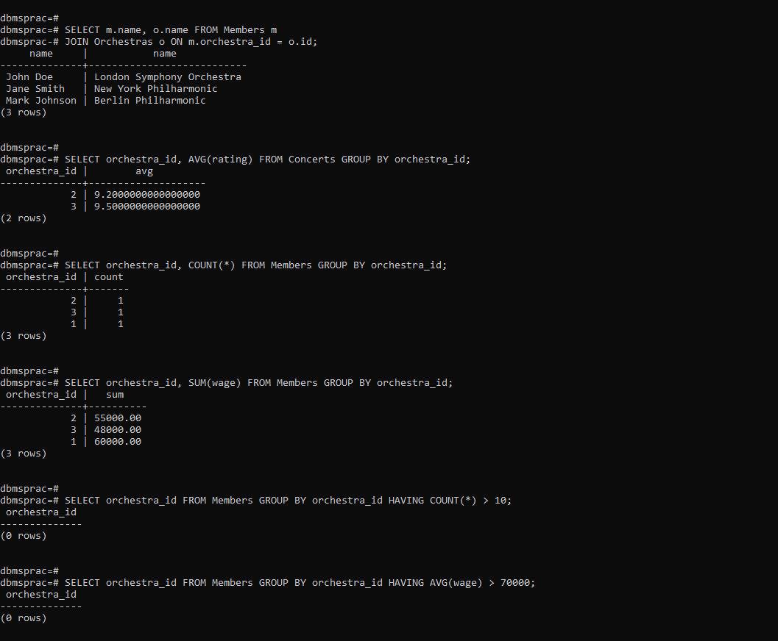

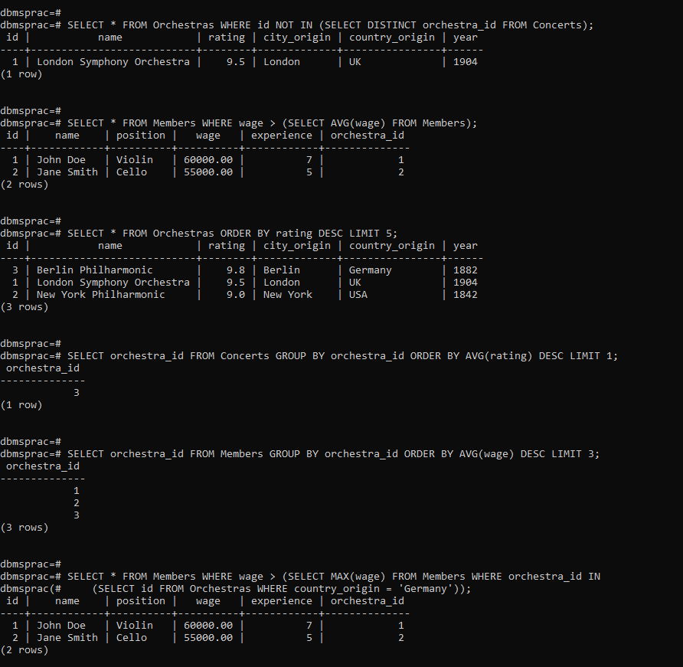

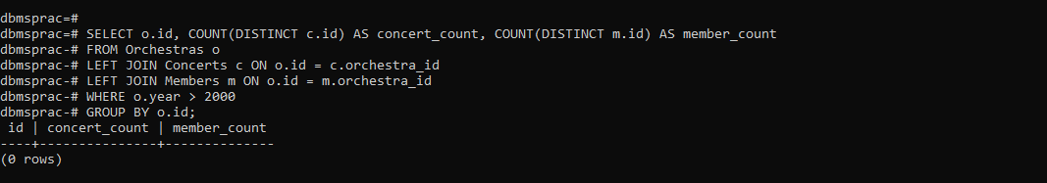

**FAQs:**

1. What do you mean by Nested Queries?

Nested queries, also known as subqueries, are SQL queries placed inside another query. They are used when a query depends on the results of another query for its execution.

1. What is the order of query execution in Nested Queries?

• The innermost subquery is executed first.

• The result of the inner query is passed to the outer query.

• The outer query then uses this result to complete its execution.

1. What do you mean by sub query?

A subquery is a SQL query that is embedded within another SQL statement. It can be used in SELECT, FROM, or WHERE clauses to retrieve data that will be used by the main query.